AutoRestTest
An AI-Powered Collaborative Platform for Automated REST API Testing

Software Requirement Specification
& Analysis Report

July 2026

Table of Contents
1. Introduction 4
2. Quality Function Deployment 5
2.1 Normal Requirements 5
2.2 Expected Requirements 5
2.3 Exciting Requirements 5
3. Usage Scenario 7
3.1 Authentication System 7
User Sign Up 7
User Login 7
3.2 Project Management 7
Create Project 7
Manage Projects 7
3.3 API Specification Management 7
Upload OpenAPI Specification 8
Automated API Specification Generation 8
3.4 Test Suite Management 8
Automatic Test Suite Generation 8
Save and Reuse Test Suites 8
3.5 Test Execution 8
One-Click API Testing 8
Running Tests 8
Test Alerts and Notifications 9
3.6 Test Results and Reports 9
Viewing Test Results 9
Test Reports and Analytics 9
Test Failure Explanation 9
Test Execution History 9
Export Test Reports 9
3.7 Team Collaboration 10
Inviting Team Members 10
Role Management 10
4. Use Case Diagrams 11
Level 0 — System Overview 12
Level 1 — Full System (Role-Based) 14
Level 1.1 — Authentication 15
Level 1.2 — Project & Endpoint Management 17
Level 1.3 — API Specification Management 19
Level 1.4 — Test Suite Management 20
Level 1.5 — Test Execution 21
Level 1.6 — Test Results & Reports 22
Level 1.7 — Team Collaboration 23
5. Activity Diagrams 25
5.1 Authentication 26
5.2 Project & Endpoint Management 27
5.3 API Specification Management 28
5.4 Test Suite Management 30
5.5 Test Execution 32
5.6 Test Results & Reports 33
5.7 Team Collaboration 34
6. Data-Based Modeling 36
6.1 Noun Listing 36
6.2 Probable Data Objects 39
6.3 Relationship Between Data Objects 40
6.4 ER Diagram 41
6.5 Schema 42

1. Introduction
As modern web services grow increasingly dependent on REST APIs, ensuring the correctness and reliability of these APIs has become a critical concern for development teams. Testing REST APIs is a challenging and time-consuming task — as APIs grow in size and complexity, exploring all possible inputs, operation sequences, and edge cases manually becomes impractical, repetitive, and error-prone. Existing automated testing tools often fall short in handling the interdependencies between API operations, leading to incomplete test coverage and reduced effectiveness in detecting faults. At the same time, teams working in continuous development workflows need a shared environment where testing activities, results, and project data can be organised, stored, and reused collaboratively. This report delves into the detailed requirements for AutoRestTest, an AI-powered collaborative platform that enables development and quality-assurance teams to automate REST API testing intelligently, manage multiple projects and test suites through a centralised dashboard, and work together to improve API reliability with minimal manual effort.

2. Quality Function Deployment

2.1 Normal Requirements
- User Authentication: Secure login and sign-up processes for users to create and manage their accounts on the platform.
- Project Management: Users must be able to create, update, and delete API testing projects to organise their work.
- API Specification Upload: Users must be able to upload an OpenAPI specification file to define the API they want to test.
- Test Execution: The platform must be able to run automated tests against a target API based on the uploaded specification.
- Test Result Viewing: Users must be able to see the outcome of each test run, including which endpoints were tested and what responses were received.
- Secure Data Storage: All account information, uploaded specifications, and test results must be stored securely and kept private to each user.
- Test Alerts: Users must be notified when a test is completed, when a run fails, or when a system error occurs during execution.

2.2 Expected Requirements
- Automatic Test Suite Generation: Users expect the platform to automatically generate a comprehensive set of test cases directly from the uploaded API specification.
- Multi-Project Dashboard: Users expect a centralised dashboard to create, manage, and switch between multiple API testing projects.
- Team Collaboration: Users expect to invite team members into a project and assign roles such as admin, tester, or viewer.
- Test Execution History: All past test runs will be saved with their timestamps and outcomes so users can review and track API behaviour over time.
- Test Reports and Analytics: Users expect a detailed report after each test run showing the distribution of HTTP response codes received, any server-side failures detected, and the proportion of API endpoints that were covered.
- Reuse Test Suites: Users expect to save test configurations as named suites that can be re-executed in the future without reconfiguration.
- Export Test Reports: Users expect to download test results and reports in standard formats such as PDF or CSV for documentation and sharing.

2.3 Exciting Requirements
- Automated API Specification Generation: The system can automatically generate an OpenAPI specification from uploaded source code.
- Test Failure Explanation: When a test failure or server error is detected, the platform provides a plain-language description of what went wrong and which request caused it.
- One-Click API Testing: A single action triggers the entire testing process — from reading the API specification to generating tests, running them, and producing a report.

3. Usage Scenario

3.1 Authentication System
The system will have an authentication system with two options: sign up for new users and log in for users who already have an account.

User Sign Up
A new user will begin registration by visiting the platform's sign-up page and clicking the Create Account button. The user will need to provide a valid email address, a username, and a password. The system will validate the uniqueness of the username and email and the format of the email address.

User Login
Already registered users can log in by providing their email address and password on the login page. The system will maintain user sessions securely, allowing users to remain logged in without having to authenticate repeatedly. Users will also have the option to keep their login details saved for quicker access in future sessions.

3.2 Project Management
Once logged in, users will be taken to the main dashboard where all their projects are displayed. The system will allow users to create, manage, and organise multiple API testing projects from a single centralised interface.

Create Project
A user can create a new project by clicking the New Project button on the dashboard. The user will provide a project name and an optional description. Once created, the project will appear on the dashboard and the user will be taken to the project workspace where they can begin setting up their testing environment.

Manage Projects
The dashboard will display all projects belonging to the user along with their names, creation dates, and last activity. Users can open, rename, or delete any project from the dashboard. Users can add multiple API endpoints inside a project. Deleting a project will remove all associated specifications, test suites, and results permanently, following a confirmation prompt from the system.

3.3 API Specification Management
Before testing can begin, users need to define the API they want to test. Each project may have an API specification. The system will provide two ways to do this: uploading an existing specification file or generating one automatically from source code.

Upload OpenAPI Specification
Users can upload an OpenAPI specification file in .yaml format directly into their project. The system will parse and validate the uploaded file and display the list of detected API endpoints and operations, making them available for test generation. If the file contains errors or is not a valid specification, the system will notify the user with a description of the problem.

Automated API Specification Generation
For users who do not have an existing specification file, the system will provide an option to generate one automatically. The user can upload their API source code files and the system will analyse them to produce a valid OpenAPI specification. The generated specification will be displayed for review before the user proceeds, and it can be used as the basis for testing in the same way as a manually uploaded file.

3.4 Test Suite Management
Once an API specification is available within the project, the system will allow users to generate, save, and reuse test suites for repeated testing.

Automatic Test Suite Generation
After a specification is uploaded or generated, the system will automatically produce a comprehensive set of test cases covering the detected API endpoints and operations. The generated test suite will be displayed to the user showing each test case, its target endpoint, and the HTTP method that will be used. Users are not required to write or configure any test cases manually.

Save and Reuse Test Suites
The test suite will be saved for future use. Saved test suites will appear in the project's Test Suites section and can be re-executed at any time without regenerating or reconfiguring them. This is particularly useful for regression testing, where the same suite needs to be run repeatedly after API changes.

3.5 Test Execution
When a test suite is executed, the system will send automated requests to the target API, collect the responses, and track the progress in real time.

One-Click API Testing
The system will provide a single Run button that, when clicked, triggers the entire testing pipeline automatically. The system will read the active specification, generate test cases, execute all tests against the target API, and produce a full report — all without requiring any additional input from the user. This allows a team to run a complete API test in a single action.

Running Tests
Users can initiate a test run by selecting a test suite and clicking the Run button. The system will display a live progress indicator showing which endpoints are currently being tested and how many have been completed. Users can monitor the execution as it progresses without needing to refresh the page.

Test Alerts and Notifications
Once a test run is complete, the system will send the user a notification confirming completion along with a brief summary of the outcome. If the run encounters a failure — such as the target API being unreachable, an unexpected server error, or a system-level issue during execution — the user will be notified immediately with a description of what went wrong.

3.6 Test Results and Reports
After each test run, the system will store the results and provide detailed reporting and analysis options for the user to review.

Viewing Test Results
Users can open any completed test run to see a full breakdown of the results. The results page will show each endpoint that was tested, the HTTP method used, the response received, and whether the test passed or failed. Users can filter the results by endpoint, response status, or HTTP response code to focus on specific areas of interest. In addition, the system records every individual request the engine sent during the run, so users can inspect the exact request and response captured for each call.

Test Reports and Analytics
The system will generate a summary report for each completed test run showing the distribution of HTTP response codes received across all tested endpoints, any server-side failures that were detected, and the proportion of the API's endpoints that were covered during the run. This gives the team a complete picture of how the API performed.

Test Failure Explanation
When a server-side failure or unexpected response is detected, the system will provide a plain-language explanation describing which request triggered the failure, what response was received, and what the likely cause may be. This reduces the time users spend investigating and diagnosing issues after a test run.

Test Execution History
The system will maintain a complete history of all test runs for each project. Users can access the history from the project workspace and see a list of past executions with their timestamps, the test suite used, and a summary of outcomes. Any past run can be opened to review its full results in the same way as a recent run.

Export Test Reports
Users can download the results and report of any completed test run in standard formats such as PDF or CSV. The exported file will contain the full results breakdown, the analytics summary, and the details of any detected failures, allowing users to share test outcomes with stakeholders or include them in project documentation.

3.7 Team Collaboration
The system will allow multiple users to collaborate within a shared project. The project owner can invite team members and assign them roles to control what each member can see and do within the project.

Inviting Team Members
The project owner or an admin can invite other users to join the project by entering their email address. The invited user will receive an invitation with a link to accept it. Once accepted, the user will be added to the project and it will appear on their dashboard.

Role Management
Each team member is assigned a role that determines their level of access. An admin can manage project settings, invite or remove members, and execute test runs. A tester can upload specifications, generate test suites, and run tests. A viewer can only see test results and reports without making any changes to the project. The project owner can update a member's role or remove them from the project at any time.

4. Use Case Diagrams
Use case diagrams give a non-technical view of the overall system — who uses it (the actors) and what they can do (the use cases). AutoRestTest has five primary (human) actors and three secondary (external system) actors.
Primary actors. A Visitor is an unauthenticated user who can only sign up or log in. A Registered User owns an account and can create projects and accept invitations. Within a project, a member holds one of four roles that form a permission hierarchy — Viewer (read-only) ⊂ Tester (specs, suites, runs) ⊂ Admin (collaboration, settings) ⊂ Project Owner (full control). Each higher role inherits every capability of the roles below it.
Secondary actors. The LLM API supplies AI-generated request values, failure explanations, and specification generation. The Target REST API is the external service under test. The Email Service delivers collaboration invitations.

Level 0 — System Overview
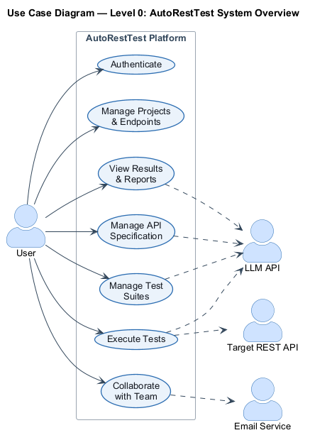
Figure 1: Use case diagram — Level 0: AutoRestTest system overview
At the highest level the platform offers seven capability groups: Authentication, Project & Endpoint Management, API Specification Management, Test Suite Management, Test Execution, Results & Reports, and Team Collaboration. Each is decomposed in the Level 1 diagrams that follow.

Level 1 — Full System (Role-Based)
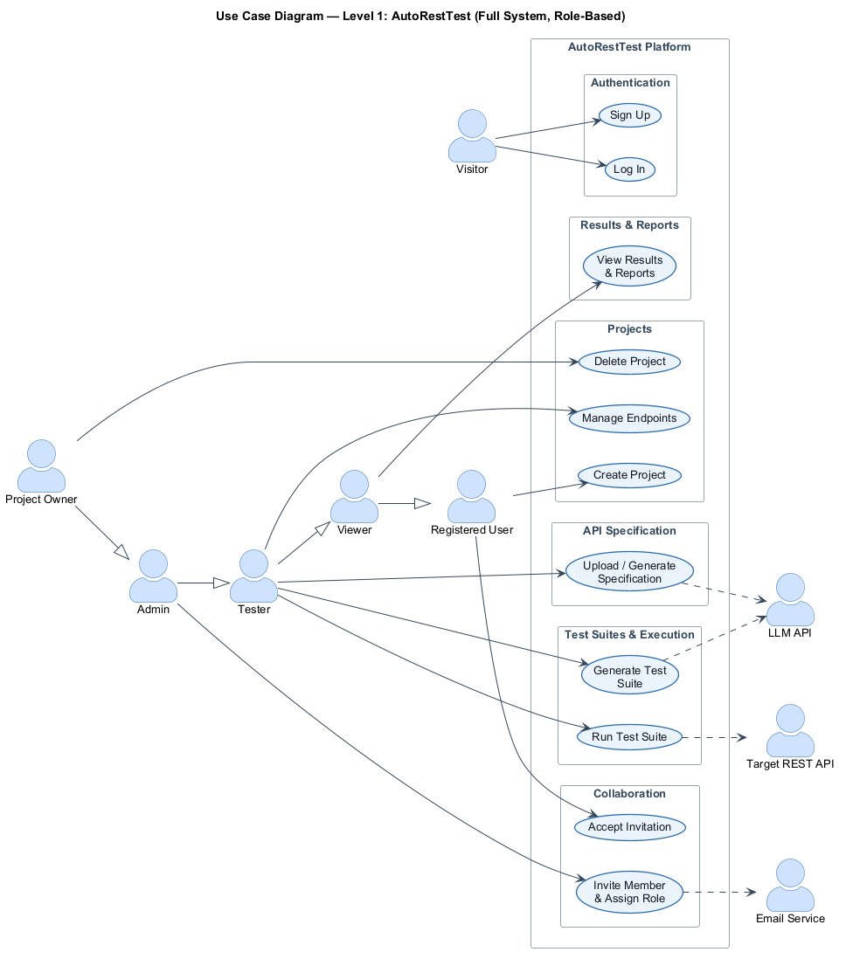
Figure 2: Use case diagram — Level 1: Full system, role-based
The Level 1 diagram introduces the role hierarchy and connects each role to the capabilities it unlocks: a Visitor authenticates; a Registered User creates projects and accepts invitations; a Viewer reads results and reports; a Tester manages specifications, generates suites and runs tests; an Admin manages collaboration; and the Owner has full control including project deletion.

Level 1.1 — Authentication
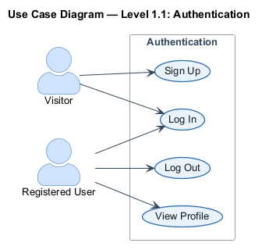
Figure 3: Use case diagram — Level 1.1: Authentication
- Use Case Name: Authentication
- Primary Actors: Visitor, Registered User
- Secondary Actors: —
Action–Reply
- Action: Visitor opens the sign-up page and submits a username, email, and password.
- Reply: System validates email format and the uniqueness of the username and email, creates the account, and issues an authentication token.
- Action: Visitor submits email and password on the login page.
- Reply: System verifies the credentials and returns a session token, keeping the user signed in across sessions.
- Action: Registered User opens their profile.
- Reply: System returns the current account details.
- Action: Registered User logs out.
- Reply: System ends the session.

Level 1.2 — Project & Endpoint Management
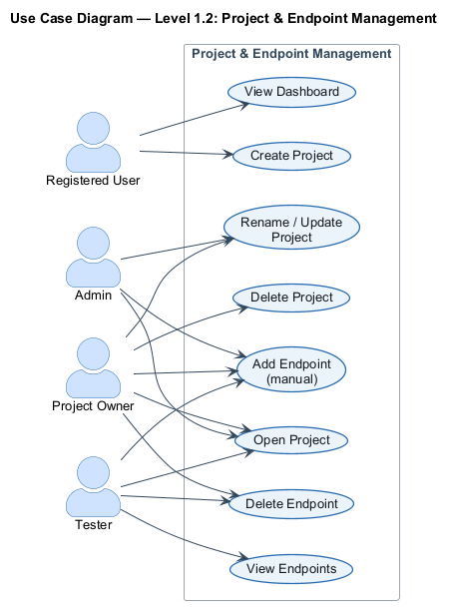
Figure 4: Use case diagram — Level 1.2: Project & Endpoint Management
- Use Case Name: Project & Endpoint Management
- Primary Actors: Registered User, Project Owner, Admin, Tester
- Secondary Actors: —
Action–Reply
- Action: User opens the dashboard.
- Reply: System lists all projects the user owns or belongs to, with names, creation dates, and last activity.
- Action: User creates a project with a name and optional description.
- Reply: System creates the project, assigns the user as Owner, and opens the project workspace.
- Action: Owner or Admin renames or updates a project.
- Reply: System saves the changes.
- Action: Owner deletes a project.
- Reply: System requests confirmation, then permanently removes the project and all its specifications, endpoints, suites, and results.
- Action: Tester adds an endpoint manually (path + HTTP method).
- Reply: System validates uniqueness and adds it to the project's endpoint list.
- Action: Tester deletes an endpoint.
- Reply: System removes it after confirmation.

Level 1.3 — API Specification Management
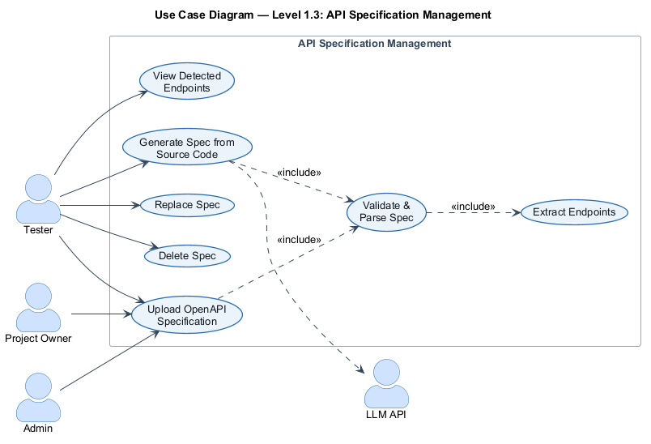
Figure 5: Use case diagram — Level 1.3: API Specification Management
- Use Case Name: API Specification Management
- Primary Actors: Tester, Project Owner, Admin
- Secondary Actors: LLM API
Action–Reply
- Action: Tester uploads an OpenAPI 3.0 specification file.
- Reply: System validates and parses the file, extracts its endpoints and operations, and displays them; if the file is invalid it reports the problem.
- Action: Tester chooses to generate a specification from source code.
- Reply: System analyses the source through the LLM API and produces a specification for review.
- Action: Tester replaces or deletes the specification.
- Reply: System updates the stored spec and re-derives the endpoint list.

Level 1.4 — Test Suite Management
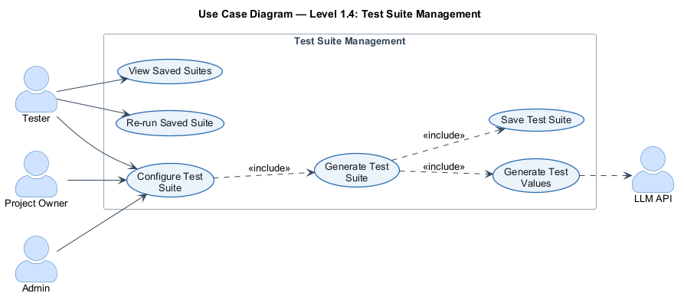
Figure 6: Use case diagram — Level 1.4: Test Suite Management
- Use Case Name: Test Suite Management
- Primary Actors: Tester, Project Owner, Admin
- Secondary Actors: LLM API
Action–Reply
- Action: Tester configures a test suite (target URL, time budget, mutation rate).
- Reply: System records the configuration.
- Action: Tester triggers test-suite generation.
- Reply: System, using the testing engine with the LLM API for value generation, produces test cases covering the detected endpoints and saves the suite.
- Action: Tester views saved suites.
- Reply: System lists the project's saved suites.
- Action: Tester re-runs a saved suite.
- Reply: System re-executes it without reconfiguration.

Level 1.5 — Test Execution
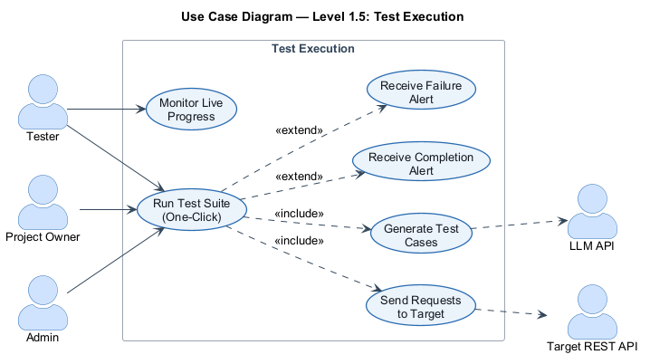
Figure 7: Use case diagram — Level 1.5: Test Execution
- Use Case Name: Test Execution
- Primary Actors: Tester, Project Owner, Admin
- Secondary Actors: Target REST API, LLM API
Action–Reply
- Action: Tester selects a suite and clicks Run (one-click).
- Reply: System starts an asynchronous job that generates test cases and sends requests to the target API.
- Action: Tester monitors execution.
- Reply: System shows live progress (endpoints tested and completed) without requiring a page refresh.
- Action: (extend) The run finishes successfully.
- Reply: System sends a completion alert with a summary of the outcome.
- Action: (extend) The run fails (target unreachable, server error, or system error).
- Reply: System sends a failure alert describing what went wrong.

Level 1.6 — Test Results & Reports
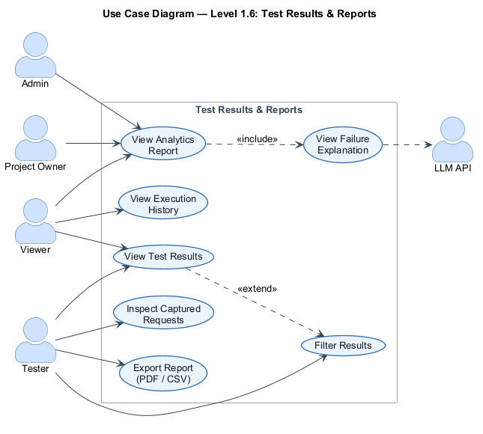
Figure 8: Use case diagram — Level 1.6: Test Results & Reports
- Use Case Name: Test Results & Reports
- Primary Actors: Viewer, Tester, Admin, Project Owner
- Secondary Actors: LLM API
Action–Reply
- Action: User opens a completed test run.
- Reply: System shows each tested endpoint, the HTTP method used, the response received, and pass/fail.
- Action: User filters results by endpoint, response status, or HTTP response code.
- Reply: System narrows the displayed results.
- Action: User inspects the captured requests.
- Reply: System shows every request/response the engine sent during the run, in order.
- Action: User views the analytics report.
- Reply: System shows the HTTP response-code distribution, endpoint coverage, and server-failure count; failure explanations are generated through the LLM API.
- Action: User opens the execution history.
- Reply: System lists past runs with timestamps and outcomes, each openable in full.
- Action: User exports a report as PDF or CSV.
- Reply: System produces a downloadable file containing the results, analytics, and detected failures.

Level 1.7 — Team Collaboration
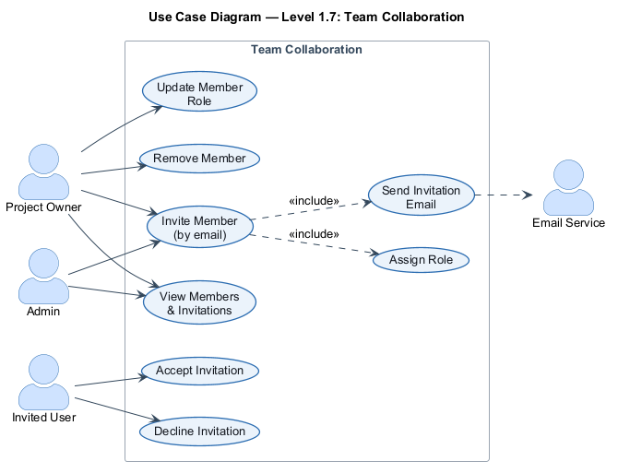
Figure 9: Use case diagram — Level 1.7: Team Collaboration
- Use Case Name: Team Collaboration
- Primary Actors: Project Owner, Admin, Invited User
- Secondary Actors: Email Service
Action–Reply
- Action: Owner or Admin invites a member by email and assigns a role.
- Reply: System creates a pending invitation with a unique token and sends an invitation email.
- Action: Invited User accepts or declines the invitation via the link.
- Reply: System adds the user to the project with the assigned role, or marks the invitation declined.
- Action: Owner updates a member's role or removes a member.
- Reply: System applies the change.
- Action: Owner or Admin views members and pending invitations.
- Reply: System lists them.

5. Activity Diagrams
Activity diagrams describe the dynamic behaviour of each module as a flow of actions and decisions — from an initial state to a final state. The following seven diagrams cover the platform's modules; decision points are shown as diamonds and the paths are labelled with their conditions.

5.1 Authentication
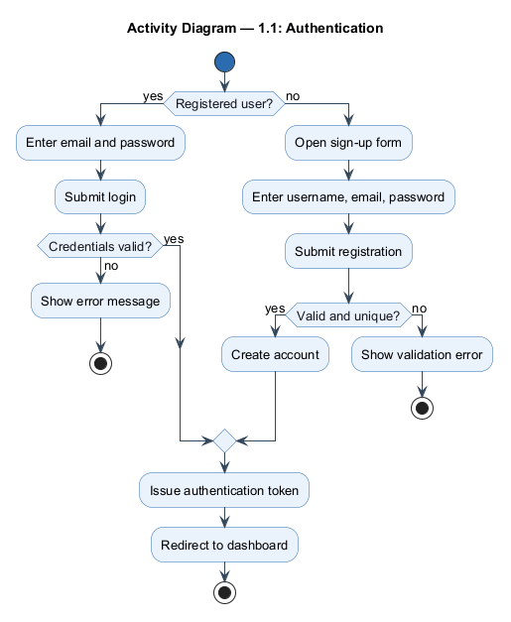
Figure 10: Activity diagram — Authentication
The flow branches on whether the visitor already has an account. A registered user enters credentials and, if they are valid, is issued an authentication token; otherwise an error is shown. A new user completes the sign-up form, which the system validates for format and uniqueness before creating the account. Both successful paths converge on issuing a token and redirecting to the dashboard.

5.2 Project & Endpoint Management
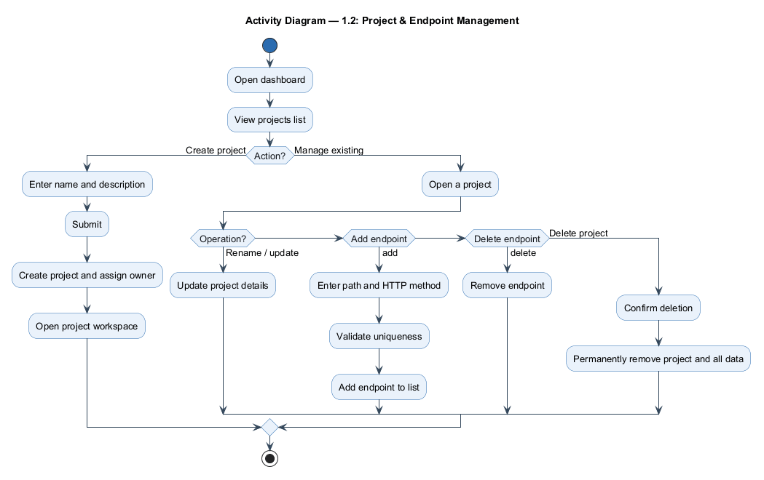
Figure 11: Activity diagram — Project & Endpoint Management
From the dashboard the user either creates a new project — supplying a name and optional description, after which the project is created with the user as owner — or manages an existing one. Managing a project branches into renaming/updating it, adding an endpoint (validated for uniqueness), deleting an endpoint, or deleting the entire project after a confirmation prompt.

5.3 API Specification Management
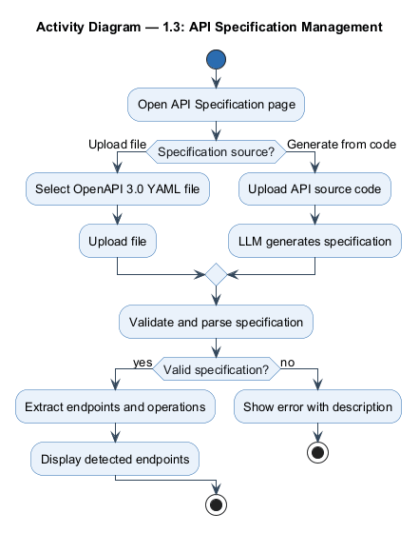
Figure 12: Activity diagram — API Specification Management
The user provides a specification either by uploading an OpenAPI 3.0 YAML file or by uploading source code for the LLM to generate one. The specification is then validated and parsed: on success the endpoints and operations are extracted and displayed; on failure a descriptive error is returned.

5.4 Test Suite Management
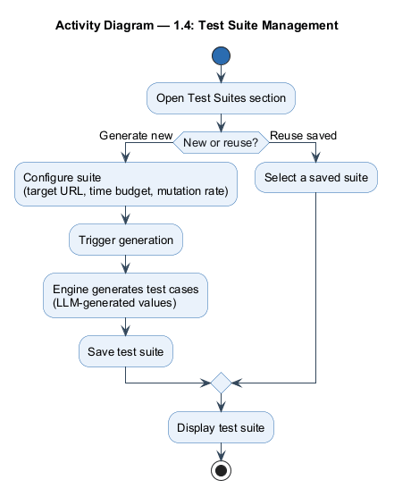
Figure 13: Activity diagram — Test Suite Management
The user either generates a new suite — configuring the target URL, time budget, and mutation rate, after which the engine generates test cases using LLM-generated values and saves the suite — or reuses a previously saved suite. Either path ends by displaying the test suite.

5.5 Test Execution
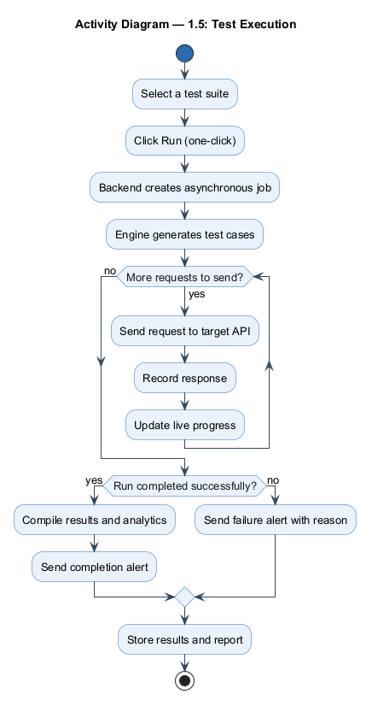
Figure 14: Activity diagram — Test Execution
Selecting a suite and clicking Run creates an asynchronous job. The engine generates test cases and then loops, sending each request to the target API, recording the response, and updating the live progress indicator. When the run finishes, a completion alert with analytics is sent on success, or a failure alert with the reason on error; the results and report are stored either way.

5.6 Test Results & Reports
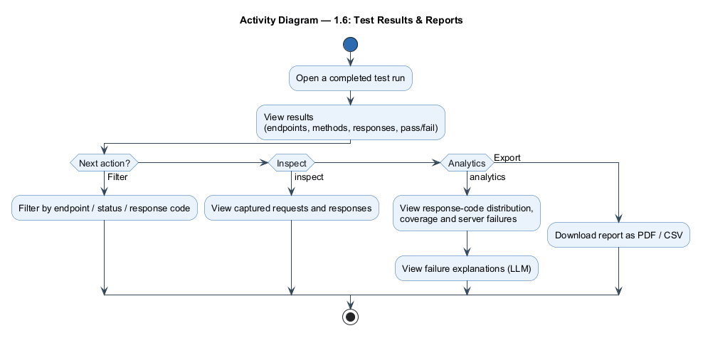
Figure 15: Activity diagram — Test Results & Reports
After opening a completed run, the user views the per-endpoint results and can then filter them, inspect the captured requests and responses, view the analytics report (response-code distribution, coverage, server failures, and LLM-generated failure explanations), or export the report as PDF/CSV.

5.7 Team Collaboration
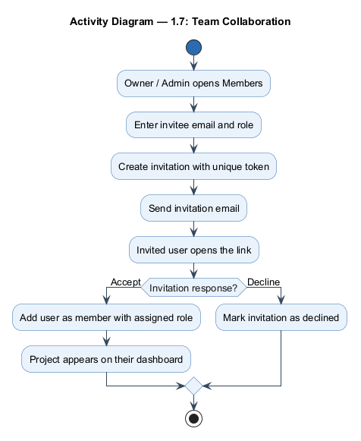
Figure 16: Activity diagram — Team Collaboration
An owner or admin enters an invitee's email and role; the system creates a tokened invitation and emails it. When the invited user opens the link, the flow branches on their response — accepting adds them to the project as a member with the assigned role (and the project appears on their dashboard), while declining marks the invitation declined.

6. Data-Based Modeling
Data-based modeling identifies the information the AutoRestTest platform must store and manage, independent of how the software is built. Following the Pressman / Coad-Yourdon analysis method, we begin by listing every noun that appears in the requirement statements and usage scenarios, separate the nouns that belong to the problem space from those that belong only to the solution space, distil the problem-space nouns into a set of data objects, describe the relationships between those objects, capture them in an Entity-Relationship (ER) diagram, and finally give the concrete schema of each object.

6.1 Noun Listing
Every noun drawn from the requirements is listed below and marked in the Problem / Solution Space column:
- P (Problem Space) — a concept essential to the application domain; it becomes a data object or an attribute of one.
- S (Solution Space) — a concept tied to a specific interface, action, external system, or file format; it does not, by itself, become stored data.
SL | Noun | Attributes | P / S
1 | Access |  | S
2 | Account |  | S
3 | Admin |  | P
4 | Alert |  | S
5 | Analytics report | response-code distribution, coverage, server-failure count | P
6 | API |  | S
7 | API specification | file name, file content, generated-by-AI flag, upload time | P
8 | Authentication |  | S
9 | Collaboration |  | S
10 | Coverage |  | P
11 | Credentials |  | S
12 | CSV |  | S
13 | Dashboard |  | S
14 | Description |  | P
15 | Email |  | P
16 | Endpoint | path, HTTP method, description, added-manually flag | P
17 | Engine |  | S
18 | Error |  | S
19 | Expiry |  | P
20 | Failure explanation |  | P
21 | File |  | P
22 | Filter |  | S
23 | HTTP method |  | P
24 | Invitation | email, role, token, status, expiry | P
25 | Job |  | S
26 | Link |  | S
27 | LLM API |  | S
28 | Login |  | S
29 | Member | role, join time | P
30 | Mutation rate |  | P
31 | Name |  | P
32 | Notification |  | S
33 | Operation |  | S
34 | Outcome |  | P
35 | Owner |  | P
36 | Password |  | P
37 | Path |  | P
38 | PDF |  | S
39 | Platform |  | S
40 | Progress indicator |  | S
41 | Project | name, description, creation time | P
42 | Report |  | P
43 | Request | method, path, URL, headers, body | P
44 | Request body |  | P
45 | Request header |  | P
46 | Response | status code, headers, body, response time | P
47 | Response code |  | P
48 | Role |  | P
49 | Session |  | S
50 | Sign up |  | S
51 | Source code |  | S
52 | Status |  | P
53 | Target API |  | S
54 | Target URL |  | P
55 | Team |  | S
56 | Test case | request, response, pass/fail, failure explanation | P
57 | Test suite | name, status, target URL, time budget, mutation rate, result summary | P
58 | Tester |  | P
59 | Time budget |  | P
60 | Timestamp |  | P
61 | Token |  | P
62 | URL |  | P
63 | User | username, email, password | P
64 | Username |  | P
65 | Viewer |  | P
66 | Workspace |  | S
67 | YAML |  | S

6.2 Probable Data Objects
Consolidating the problem-space nouns — merging synonyms (account → user, run → test suite, operation → endpoint) and promoting the recurring, data-bearing concepts to objects — yields the following data objects. Roles (admin, tester, viewer) collapse into a role attribute, and the status concepts collapse into status attributes.
SL | Data Object | Attributes
1 | User | id, username, email, password, createdAt, updatedAt
2 | Project | id, name, description, ownerId, createdAt, updatedAt
3 | ProjectMember | id, projectId, userId, role, joinedAt
4 | ProjectInvitation | id, projectId, email, role, token, status, invitedById, expiresAt, createdAt
5 | ApiSpecification | id, projectId, fileName, fileContent, generatedByAI, uploadedAt
6 | Endpoint | id, projectId, path, method, description, addedManually, createdAt
7 | TestSuite | id, projectId, name, status, jobId, targetUrl, timeBudget, mutationRate, result-summary counts, triggeredById, startedAt, completedAt, createdAt
8 | TestCase | id, testSuiteId, endpointId, requestBody, requestHeaders, statusCode, responseBody, responseTimeMs, passed, failureExplanation, createdAt
9 | RequestLog | id, testSuiteId, endpointId, seq, method, path, url, statusCode, durationMs, request/response headers & bodies, createdAt
Derived object — Report. The analytics report noun does not become a stored object: a report (HTTP response-code distribution, endpoint coverage, server-failure count, failure explanations) is computed on demand from a TestSuite together with its TestCase and RequestLog rows. It is therefore a derived data object rather than a persistent one.

6.3 Relationship Between Data Objects
Parent Object | Relationship | Child Object | Cardinality
User | owns | Project | 1 : N
Project | has | ProjectMember | 1 : N
User | is (referenced by) | ProjectMember | 1 : N
Project | has | ProjectInvitation | 1 : N
User | sends | ProjectInvitation | 1 : N
Project | has | ApiSpecification | 1 : 1
Project | contains | Endpoint | 1 : N
Project | has | TestSuite | 1 : N
User | triggers | TestSuite | 1 : N
TestSuite | produces | TestCase | 1 : N
Endpoint | tested by | TestCase | 1 : N
TestSuite | captures | RequestLog | 1 : N
Endpoint | maps | RequestLog | 1 : N
User and Project hold a many-to-many collaboration association that is resolved through the ProjectMember associative object (each row pairs one user with one project and carries the member's role).

6.4 ER Diagram
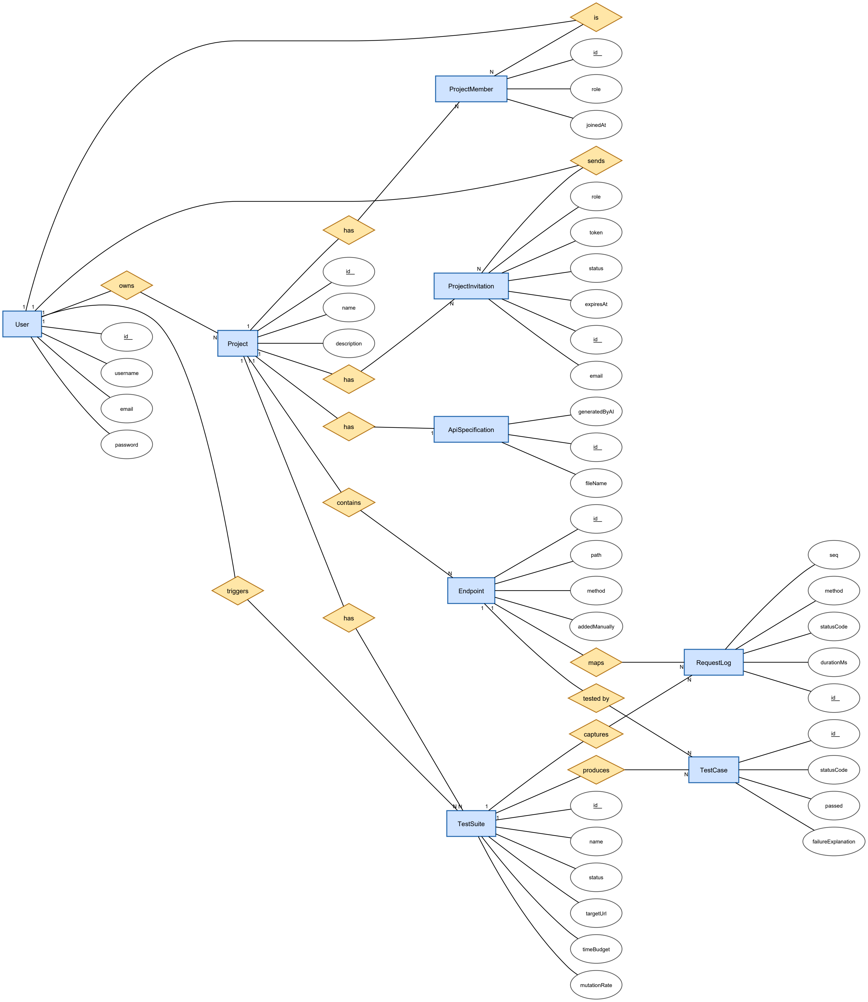
Figure 17: Entity-Relationship diagram (Chen notation)
The diagram models the nine persistent entities as rectangles, their relationships as diamonds, and their attributes as ovals with primary keys underlined; the 1 / N cardinalities are shown on the connecting edges.

6.5 Schema
The concrete schema of each data object, with data types. PK = primary key, FK = foreign key, U = unique. All identifiers are UUID strings.
User
Attribute | Data type | Key / Notes
id | UUID (String) | PK
username | String | U
email | String | U
password | String | bcrypt hash
createdAt | DateTime
updatedAt | DateTime
Project
Attribute | Data type | Key / Notes
id | UUID (String) | PK
name | String
description | String | nullable
ownerId | UUID (String) | FK → User
createdAt | DateTime
updatedAt | DateTime
ProjectMember
Attribute | Data type | Key / Notes
id | UUID (String) | PK
projectId | UUID (String) | FK → Project
userId | UUID (String) | FK → User
role | Enum { admin, tester, viewer }
joinedAt | DateTime
(projectId, userId) |  | U (composite)
ProjectInvitation
Attribute | Data type | Key / Notes
id | UUID (String) | PK
projectId | UUID (String) | FK → Project
email | String
role | Enum { admin, tester, viewer }
token | String | U
status | Enum { pending, accepted, declined, expired } | default pending
invitedById | UUID (String) | FK → User
expiresAt | DateTime
createdAt | DateTime
(projectId, email) |  | U (composite)
ApiSpecification
Attribute | Data type | Key / Notes
id | UUID (String) | PK
projectId | UUID (String) | FK → Project, U (1 : 1)
fileName | String
fileContent | Text | raw OpenAPI 3.0 YAML
generatedByAI | Boolean | default false
uploadedAt | DateTime
Endpoint
Attribute | Data type | Key / Notes
id | UUID (String) | PK
projectId | UUID (String) | FK → Project
path | String | e.g. /users/{id}
method | Enum { GET, POST, PUT, PATCH, DELETE }
description | String | nullable
addedManually | Boolean | default false
createdAt | DateTime
(projectId, method, path) |  | U (composite)
TestSuite (the test-run record — one row per execution)
Attribute | Data type | Key / Notes
id | UUID (String) | PK
projectId | UUID (String) | FK → Project
name | String | nullable
status | Enum { pending, running, completed, failed } | default pending
jobId | String | nullable — async engine job
targetUrl | String
timeBudget | Integer | seconds
mutationRate | Float | default 0.2
totalEndpoints | Integer | result summary
coveredEndpoints | Integer | result summary
totalTestCases | Integer | result summary
passedTestCases | Integer | result summary
failedTestCases | Integer | result summary
triggeredById | UUID (String) | FK → User
startedAt | DateTime | nullable
completedAt | DateTime | nullable
createdAt | DateTime
TestCase (per-endpoint request/response outcome)
Attribute | Data type | Key / Notes
id | UUID (String) | PK
testSuiteId | UUID (String) | FK → TestSuite
endpointId | UUID (String) | FK → Endpoint
requestBody | JSON | nullable
requestHeaders | JSON | nullable
statusCode | Integer | nullable
responseBody | JSON | nullable
responseTimeMs | Integer | nullable
passed | Boolean | default false
failureExplanation | String | nullable — LLM-generated
createdAt | DateTime
RequestLog (every individual request captured by the recording proxy)
Attribute | Data type | Key / Notes
id | UUID (String) | PK
testSuiteId | UUID (String) | FK → TestSuite
endpointId | UUID (String) | FK → Endpoint, nullable
seq | Integer | order within the run
method | String
path | String | concrete path hit
url | String | full forwarded URL
statusCode | Integer | nullable
durationMs | Integer | nullable
requestHeaders | JSON | nullable
requestBody | Text | nullable
requestTruncated | Boolean | default false
responseHeaders | JSON | nullable
responseBody | Text | nullable
responseTruncated | Boolean | default false
createdAt | DateTime

